**HYL-020R0500G081**

Constant current LED driver

**Product description**

* built-in constant current LED Driver
* Adjustable output current between 350 and 500mA

via DIP switch

* Max. output power 20 W
* Up to 87 % efficiency
* For luminaires of protection class I/ II
* Nominal life-time up to 50,000 h
* 5-year guarantee

**Benefits**

* Application-oriented operating window for maximumcompatibility
* Long lasting and high reliability
* PC Plastic material housing 40 x22 mm

**Interfaces**

* Terminal blocks: 45° push terminals

**Applications**

* Linear and area lighting
* Office – industrial – shop

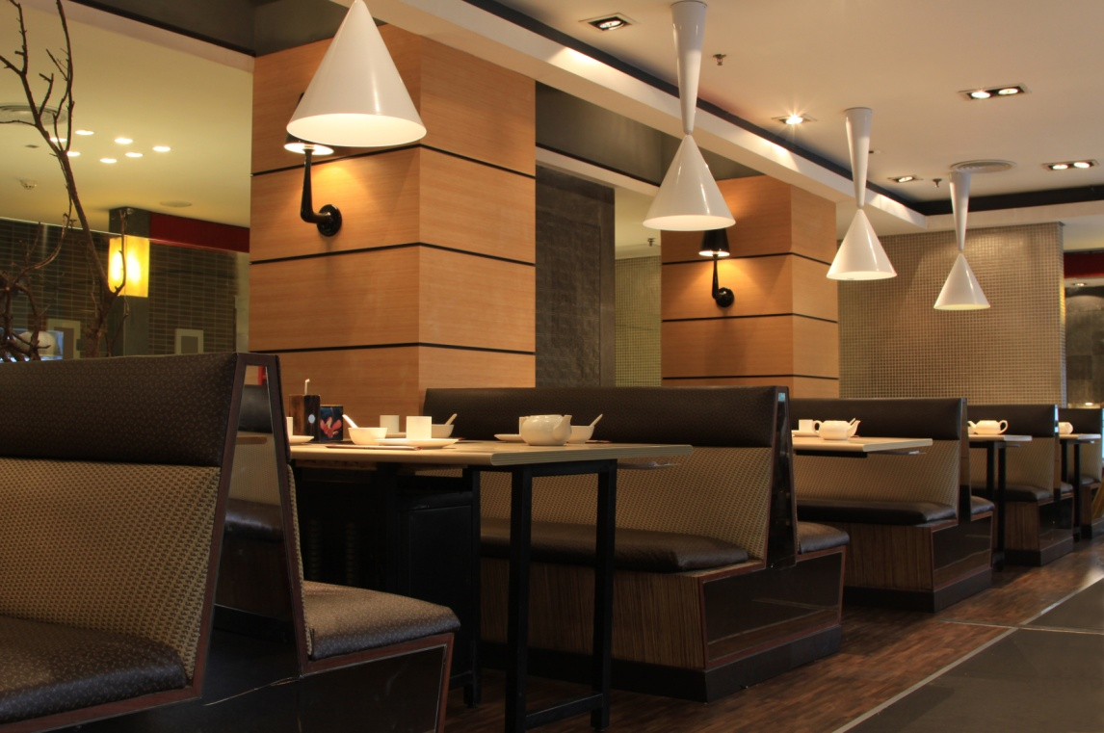

**Approval marks**





In preparation, if not already printed on product label

**Technical data**

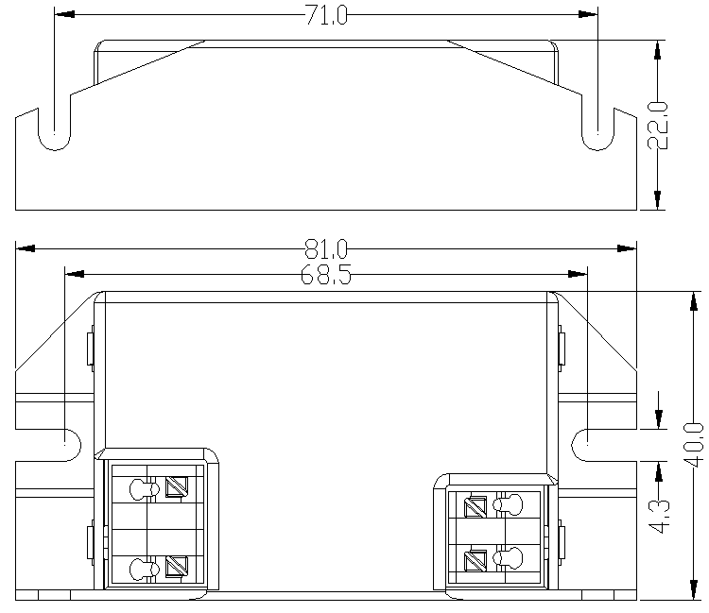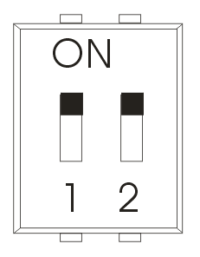

DIP Switch

Units：mm

DIP Switch

**Ordering data**

ON

OFF

●

○



**Specific technical data**

