**HYL-045DA1050G130AD_DALI 2**

Constant current LED driver

DALI Dimmable

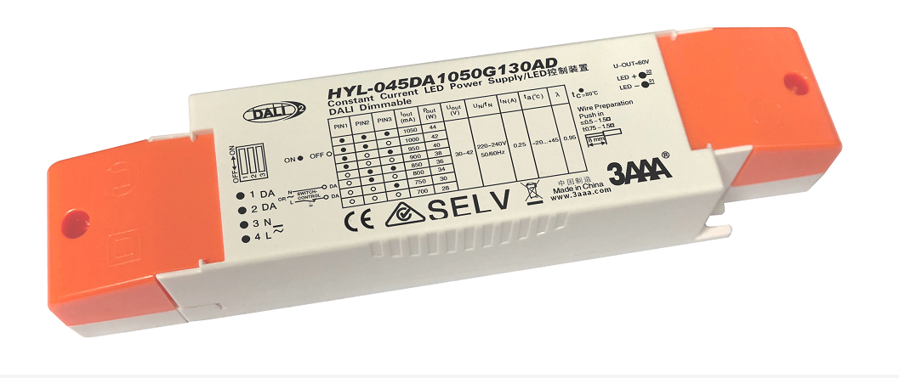

**Product description**

* Dimmable Independent constant current LED Driver
* Adjustable output current between 700 and 1050mA

via DIP switch Factory default setting 700mA gear

* Max. output power 44W
* Up to 88 % efficiency
* Power input on stand-by < 0.3 W
* Dimming range 1 – 100 %
* For luminaires of protection class I and protection class II
* Nominal life-time up to 50,000 h
* 5-year guarantee

**Benefits**

* Application-oriented operating window for maximum compatibility
* Best energy savings due to low stand-by losses and high efficiency
* Long lasting and high reliability
* Classic compact housing

**Interfaces**

* DALI （DT-6）
* SwitchDIM\PUSH DIM (with memory function)
* Terminal blocks: 45° push terminals

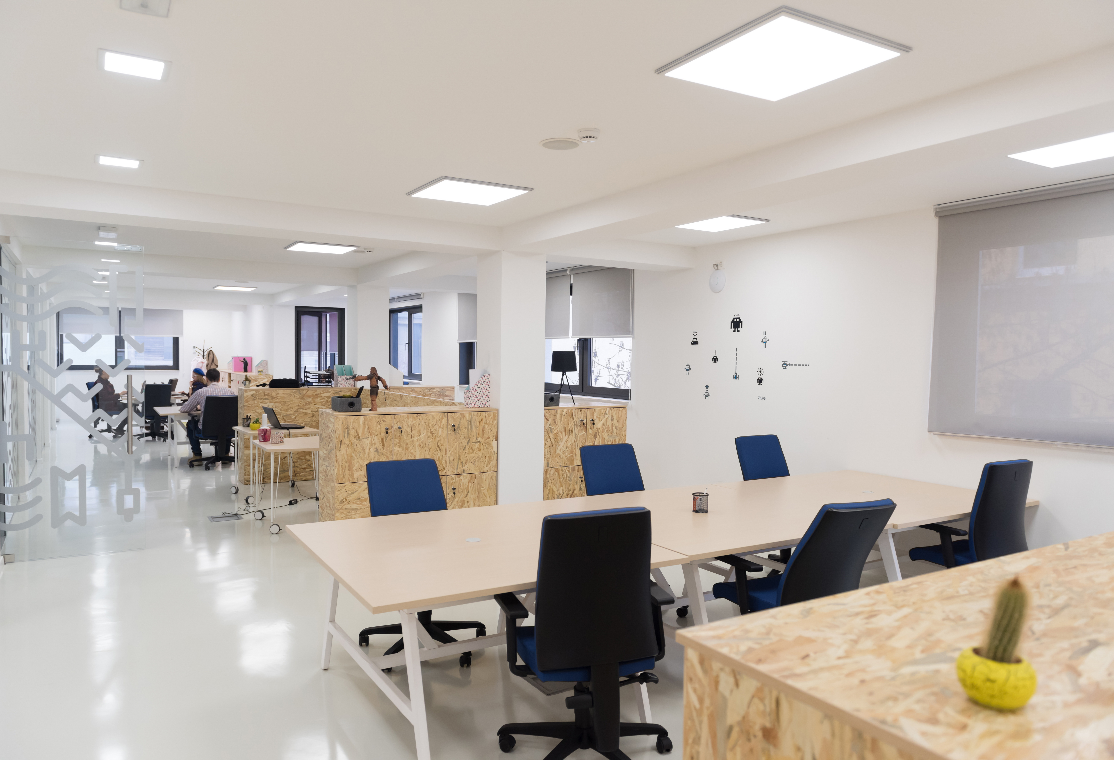

**Applications**

* Linear and area lighting
* Office – industrial – shop

**Approval marks**

 



In preparation, if not already printed on product label

**Technical data**

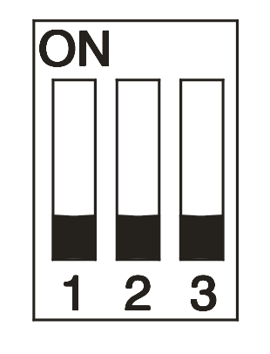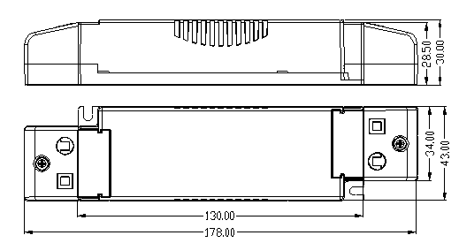

Units：mm

ON

OFF

●

○

DIP Switch

DIP Switch

ON

OFF

**Ordering data**



**Specific technical data**



①Load switching on output side is safe but not permitted

②Valid at 100 % dimming level

|  |  |
| --- | --- |
| **ACCES­SORIES** |  |

**Product description**

* Optional strain-relief set for independent applications
* Transforms the LED Driver into a fully class II compatible LED Driver

(e.g. ceiling installation)

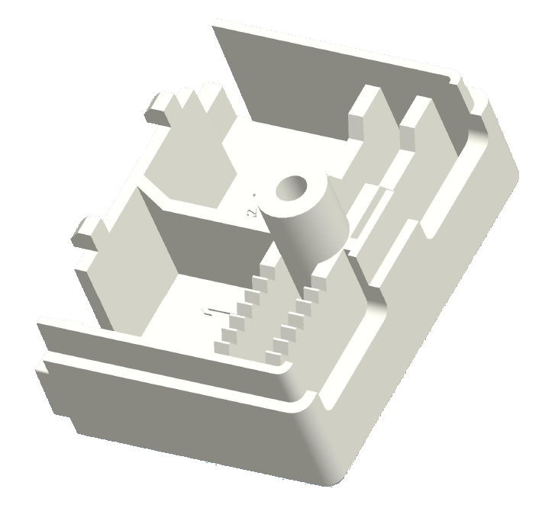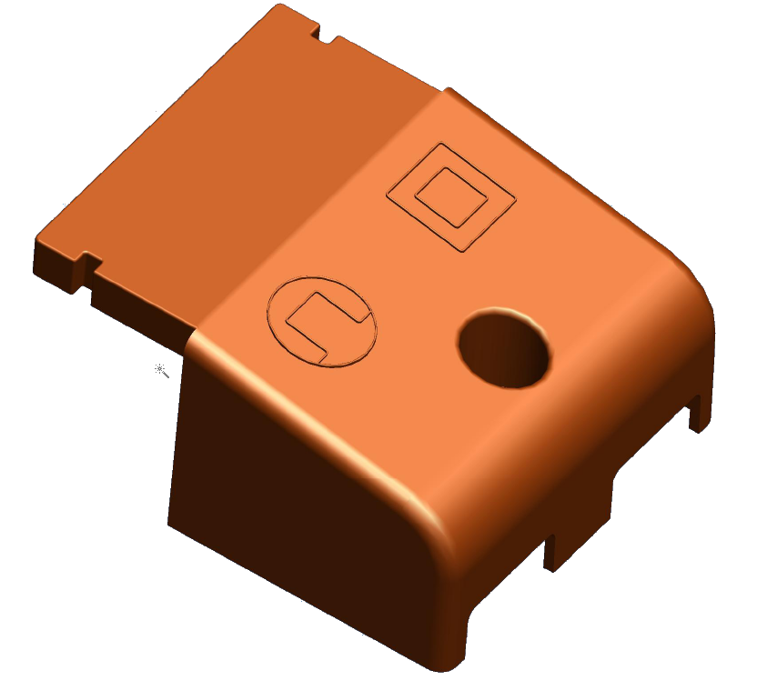

Figure 2

Figure 1

**Ordering data**

